SCREEN SHOTS

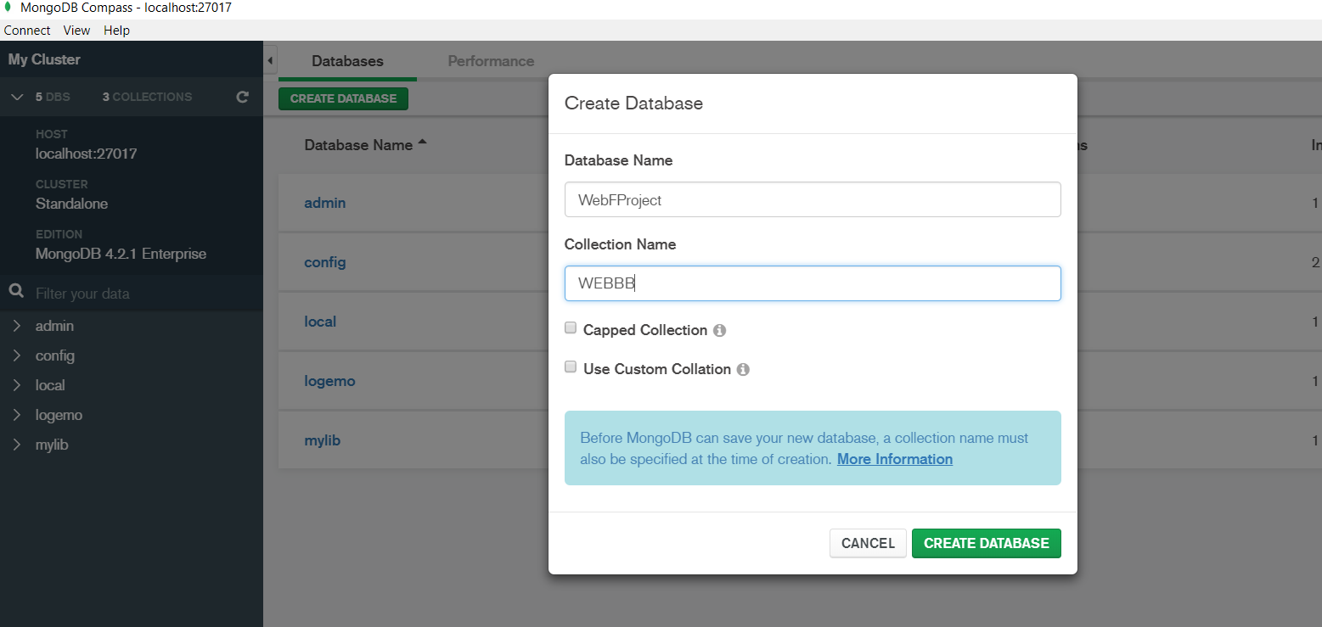

Fig1 : The database and the collection is creating on mongo database in this page

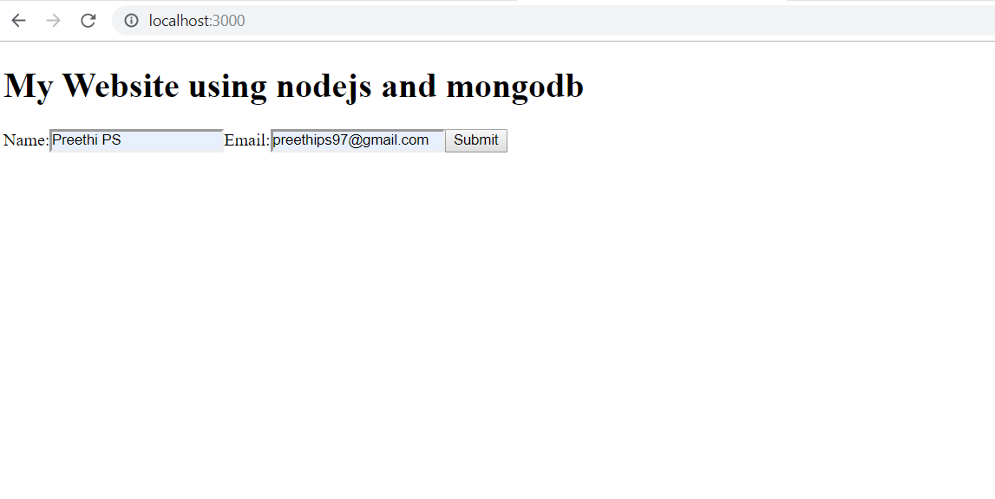

Fig 2 : In this page,name and email is entering on the website

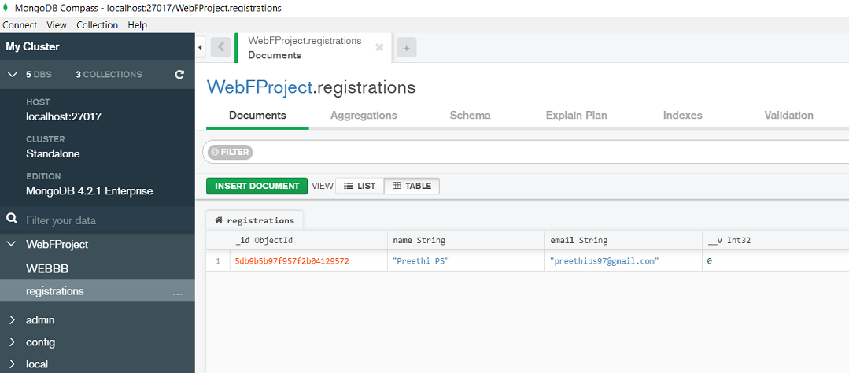

Fig 3 : Name and email which is entered in the website is stored on mongo database in table format